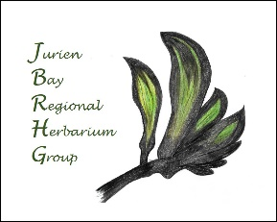
Jurien Bay Regional Herbarium Group - Plant Give-Away Day 15/06/2019
With over 800 locally sourced and grown West Australian plants to give away, the Jurien Bay Regional Herbarium Group set up the event in Dobbyn Park, by the jetty. Designed to encourage gardeners to plant suitable indigenous plants. Herbarium members had collected seed from the Shire of Dandaragan area, seeded and then grown plants in preparation for the event. Some species had been grown by Wongan Trees from our seed and others were purchased from Wongan Trees and transplanted by the Herbarium members into individual tubes or pots.
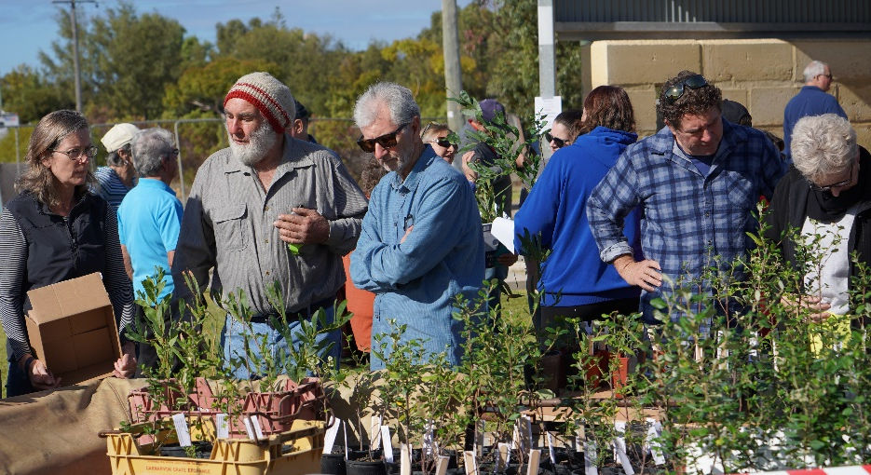
Thank you to the many eager recipients who collected plants. It is estimated that about 150 households were able to receive plants that day. Many came to chat with Don Williams from Hi-Vallee Farm to glean his wealth of wisdom regarding growing local species.
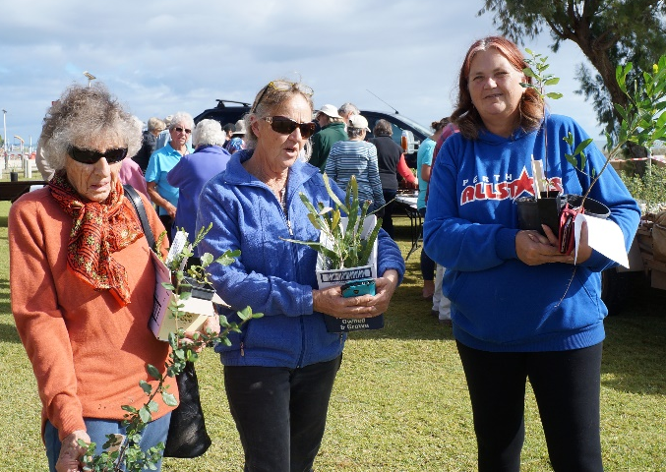
With the beautiful rain we have received over the past weeks, these healthy seedlings have the best chance to grow to maturity and beautify our gardens while attracting fauna to our gardens. What a benefit!
The Jurien Bay Regional Herbarium Group wishes to thank those organizations and individuals who supported us to present this Giveaway Event. A big “THANK YOU” to the following:
The Mary Bremner Bequest Grant Program through The Wildflower Society of WA provided funds to enable us to grow the plants.
The Jurien Bay branch of Bankwest also supported us with a grant.
The DBCA (Jurien Bay) who allowed us to grow the plants at their Carmella St premises.
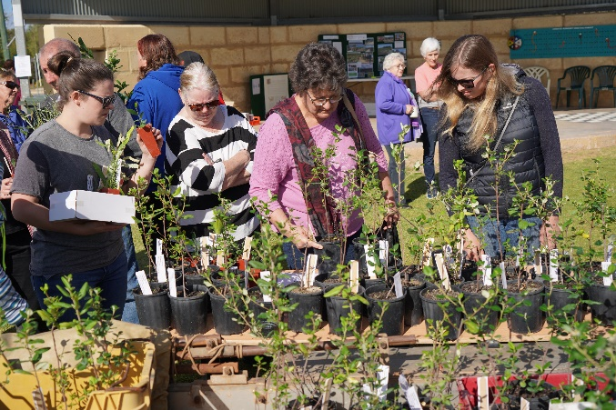
DBCA Officer, Niall Sheehy who helped and guided us through the propagation skills from seed collection to seedlings in tubes.
Don and Joy Williams who supported us at the Event, sharing their knowledge of the plants.
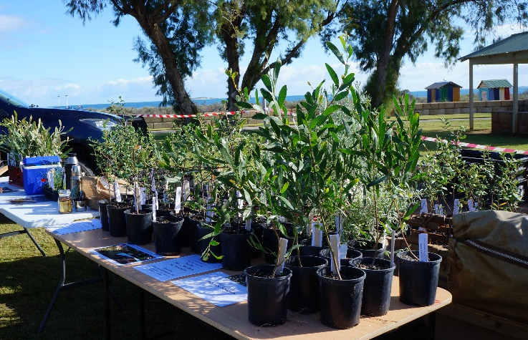
The Jurien Bay CRC who supported us with advertising and sharing our news through the Craytales articles.
The Jurien Bay Community Men’s Shed for their ongoing support and encouragement.
The Shire of Dandaragan for the preparation and use of Dobbyn Park.
All the busy and enthusiastic members of the Herbarium Group who volunteered many hours to prepare plants for the giveaway.
Thank you to everyone who made this event such a success! If you would like to be involved with this Herbarium Group, check out the contact details in the Craytales, or see our new Facebook page! There will be some Wildflower Walks in Spring. New members are always welcome!
Reported by Jenny Krieg, President, Jurien Bay Regional Herbarium Group Ph: 0418 950 189

