Registrations open 28 March
We are pleased to advise that registrations for the Biennial Conference in Kiama in September open on 28 March for all participants. Those who have expressed interest in specific tours will be able to register from 21 March.
Saturday, 10 September to Friday 16 September 2022
Kiama Pavilion, Kiama

To register, go to:
https://events.humanitix.com/2022kiama

For more information, go to the APS NSW website:
https://www.austplants.com.au/ANPSA-Biennial-Conference-2022

Tours are also open
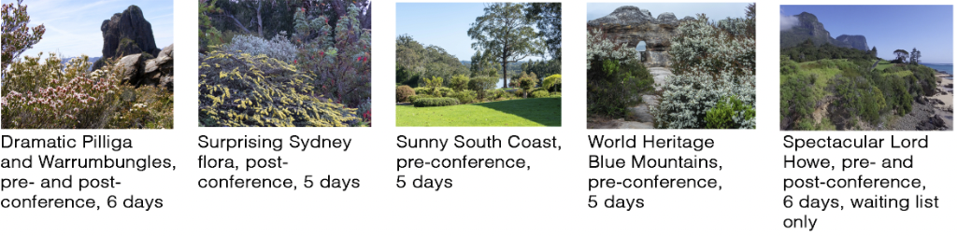

About the conference
- The conference kicks off on Saturday 10 September, with a complimentary tour of the Kiama region, followed on Sunday by a native plant sale at the Pavilion where you can also pick up any merchandise and complete registration. There is a complimentary cocktail event on the Sunday evening.
- The conference sessions and excursions run from Monday to Friday.
- Early bird pricing for the conference is a 10% discount to the full $600 price. This applies until 31 May.
- Travel insurance is strong recommended. Please check the cancellation policy on the website.
- Health requirements will be in accordance with NSW Government Health Department regulations. However, we recommend that people be up-to-date with vaccinations for their protection and the protection of others.

